# CS 255 System Design Document Template

## UML Diagrams

### UML Use Case Diagram

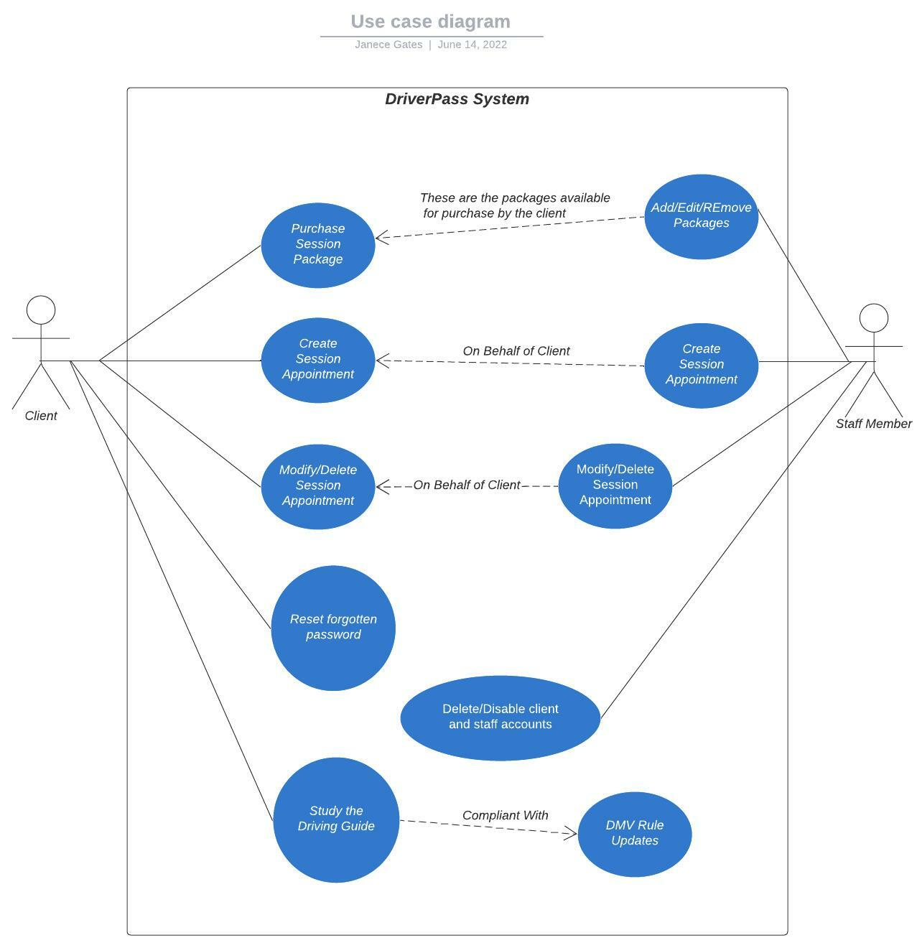

### UML Activity Diagrams

*Use Case #1: User Purchasing a Session Package*

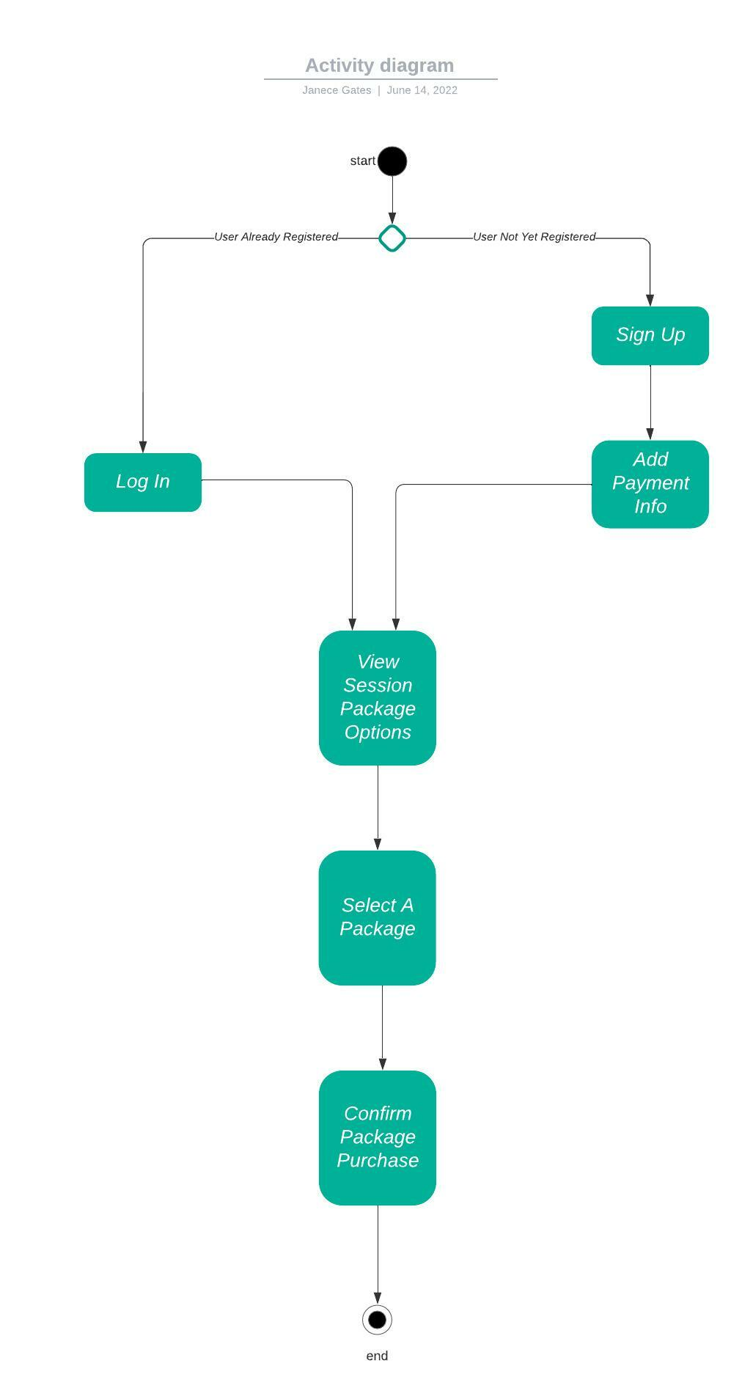

*Use Case #2: User scheduling a driving session*

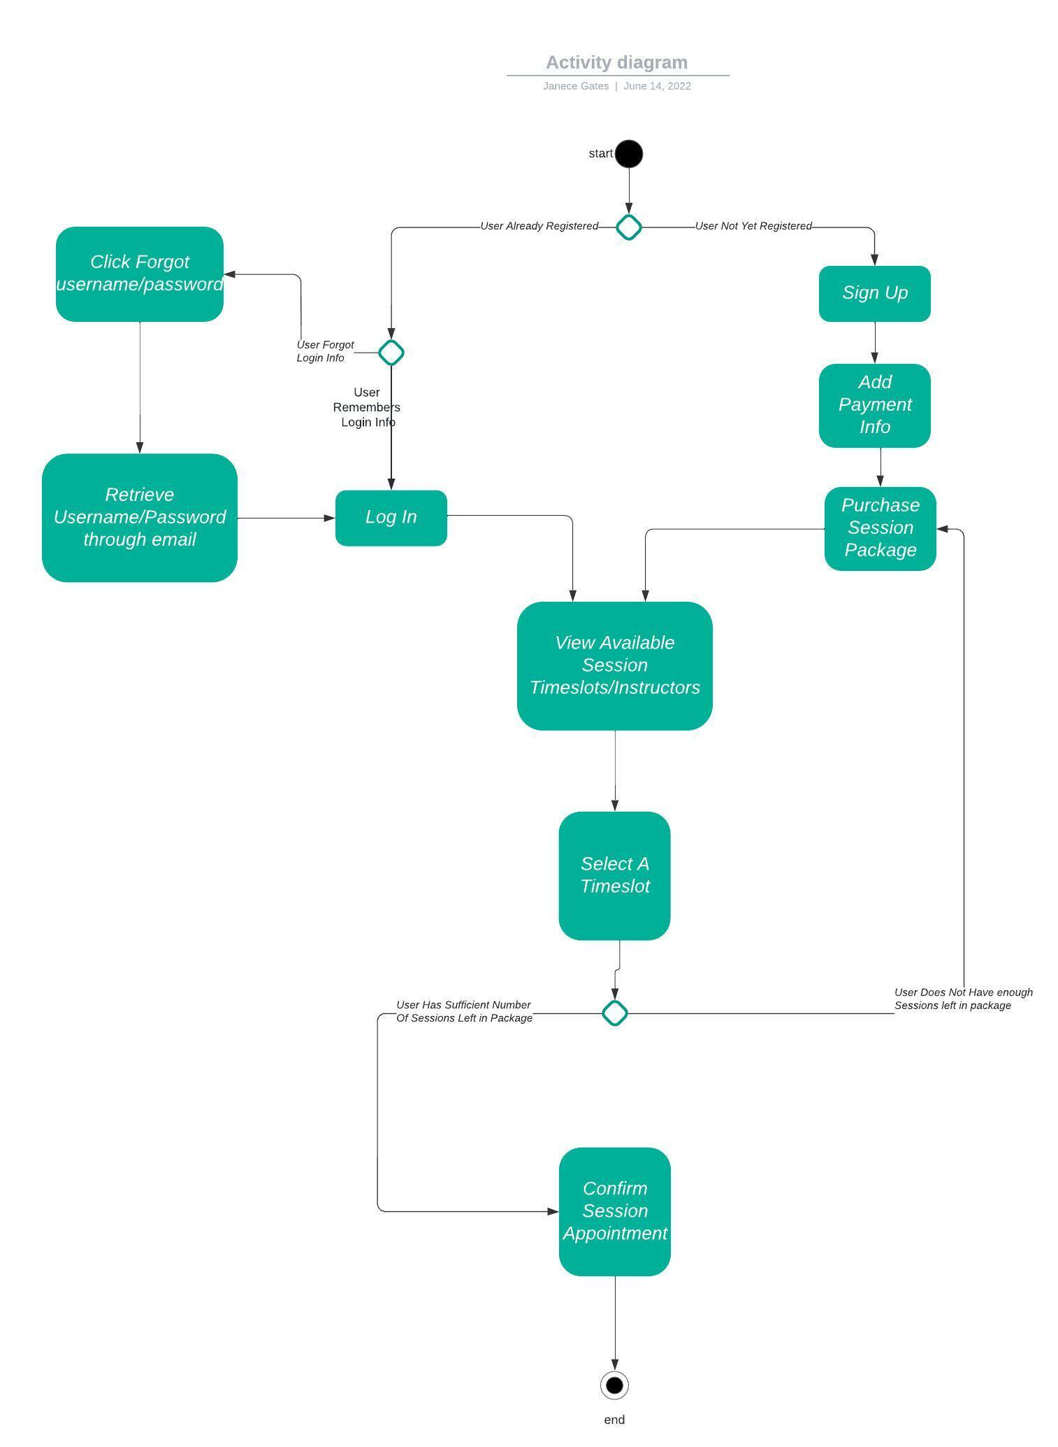

### UML Sequence Diagram

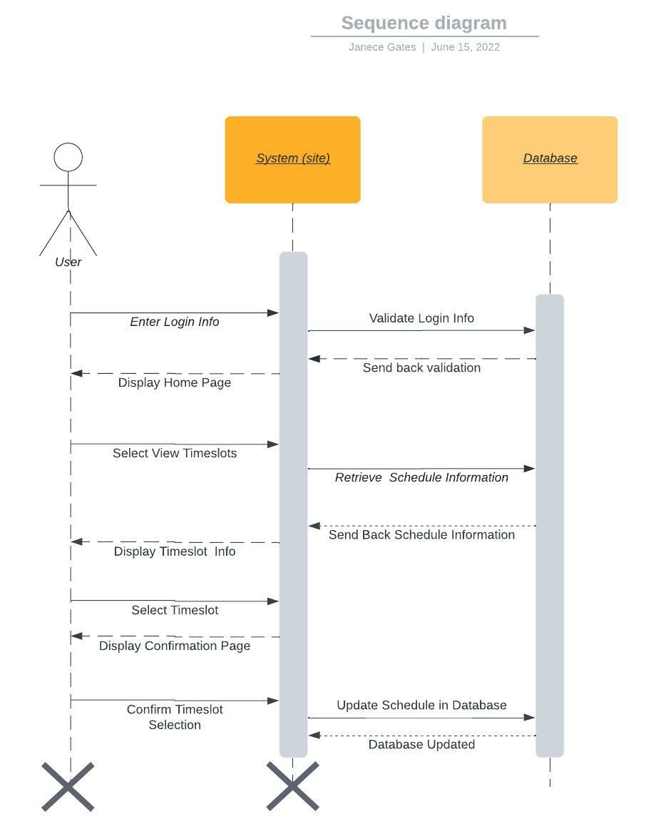

### UML Class Diagram

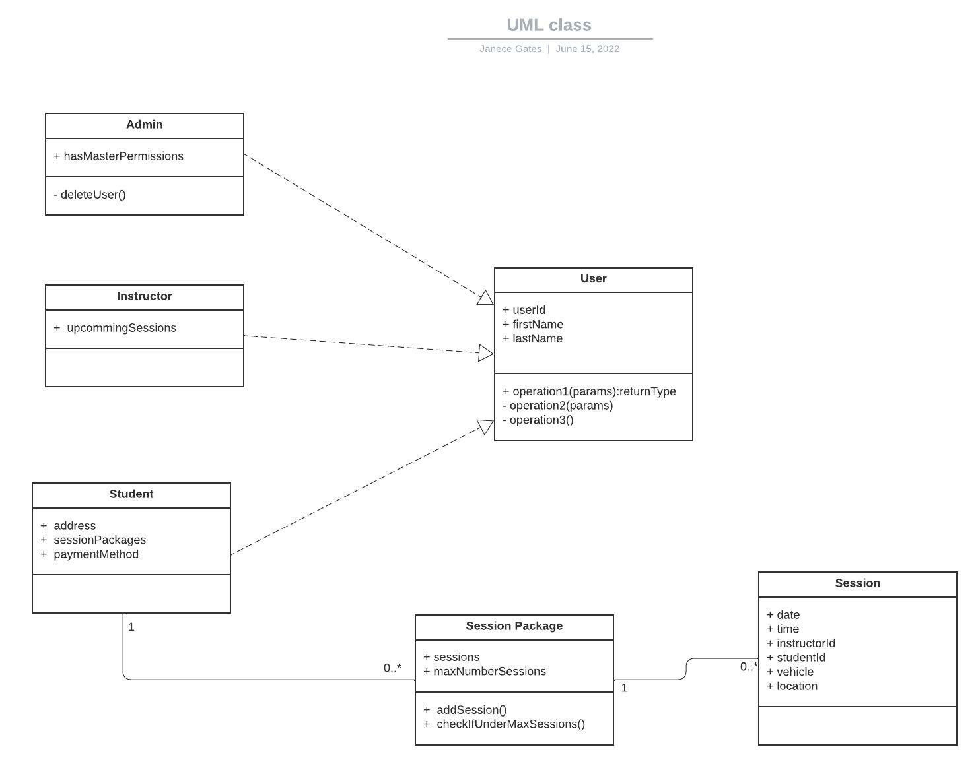

## Technical Requirements

Required Hardware:

* User will need a laptop/desktop/smartphone or any other device with internet access
* Instructors need a car

Required Software:

* Users need to use web browser to access the site

Required Tools:

* System will need to use database to store user and system info
* System will need to use a 3rd-party payment vendor to charge clients

Required Infrastructure:

* Users need to have internet access
* Users need email or cell phone for notifications/reminders
* Users need to be in an area where roads are accessible